DOCUMENT IDENTIFIER: |  | TR MDD500/240626
SUBJECT: | GVDM-MLT FIRST TIME SETUP

CONTRACT: | N/A
CDRL: | N/A

This document contains proprietary information of Israel Aerospace Industries Ltd. It may not be reproduced, copied, disclosed, or utilized in any way, in whole or in part, without the prior written consent of Israel Aerospace Industries Ltd.

Revision Status

Rev | Number of Pages | Description of Change | Author | Revision Date
- | 36 | Second Release | Michael Jack | 26.02.2025

Table of Contents

1 Scope 4
2 System Overview 4
3 Required Equipment 5
3.1 Hardware 5
3.2 Software 5
4 BIOS configuration 6
4.1 Disable Hyper-Threading 6
4.1.1 Verify Hyper-Threading Status in Task Manager (Optional) 6
4.1.2 Access BIOS by pressing the Delete key repeatedly during the computer booting sequence 7
4.1.3 Navigate to the CPU Configuration Settings 7
4.1.4 In the CPU Configuration Settings 8
4.1.5 Confirm the Change 9
4.2 Configure Serial Port 10
4.2.1 Navigate to the IT8786 Super IO Configuration 10
4.2.2 Configure Serial Port 1 10
4.2.3 Verify the Configuration 12
4.3 Configure Power On 13
4.3.1 Navigate to the Chipset Configuration Settings 13
4.4 Save and Exit BIOS 15
4.5 Verify BIOS Changes in Task Manager 16
5 System Configuration 17
5.1 Network Interface Cards Configuration 18
5.1.1 Open Command Prompt 18
5.1.2 Open Network Connections 18
5.1.3 Rename NICs 18
5.1.4 Rename NIC that uses Intel(R) Ethernet Connection (17) I219-V to AGCS 19
5.1.5 Rename NIC that uses Intel(R) I210 Gigabit Network Connection to IVDM 20
5.1.6 Configure the IP Address for the AGCS NIC 21
5.1.7 Configure the IP Address for the IVDM NIC 23
6 performance optimization 25
6.1 Disable Fast Startup 25
6.2 Configure System Power Settings 27
6.3 Configure System Display Graphics 28
6.4 Adjust Game Bar Settings 28
6.5 Adjust Visual Effects for Performance 29
6.6 Manage Startup Applications 32
6.7 Adjust Firewall & Network Protection 33
6.8 Turn Notifications Off 34
6.9 Update Time & Language Settings 35

Scope
This document defines the procedures for setting up and configuring the GVDM message routing system. This task is pivotal to the system's smooth operation.

System Overview
The Ground Video-Data Multiplexer (GVDM) is a sophisticated system that enables bidirectional Ethernet communication between the Ground Control Station (AGCS) and the Interface Video-Data Multiplexer (IVDM), utilizing two Network Interface Cards (NICs).
The GVDM system executes a dynamic real-time software application that governs message routing between the AGCS and the IVDM.
The system actively responds to three command messages issued by the AGCS, directing its operations. In turn, it provides feedback to the AGCS through two report messages.
The system controls and routes six data messages between the AGCS and the IVDM using the User Datagram Protocol (UDP) and serial communication. It relays three data messages from the AGCS to the IVDM and three from the IVDM to the AGCS.
Message routing configurations are adjusted based on initial one-time input from a predefined system configuration file and command messages.
The GVDM application supports communications with up to twenty-four AGCS computers.

Required Equipment

Hardware
- VCM-1000 28V ARX Compact Computing System.
- Two Ethernet cables.
- One serial communication cable RS422.

Software
- Installed GVDM message-routing software application.
- Installed Npcap (Network Packet Capture and Network Analysis) library for Microsoft Windows Operating System (comes with GVDM application installation).

BIOS configuration
This guide outlines disabling Hyper-Threading and configuring Serial Port 1 and Power On in BIOS.

Disable Hyper-Threading
- The computer has 24 physical CPU cores. With Hyper-Threading enabled, there are 32 logical processors. Disabling Hyper-Threading turns off logical cores.

Verify Hyper-Threading Status in Task Manager (Optional)
- Open the Task Manager
- Navigate to the Performance tab.
- Confirm that Hyper-Threading is enabled (32 logical processors are visible).
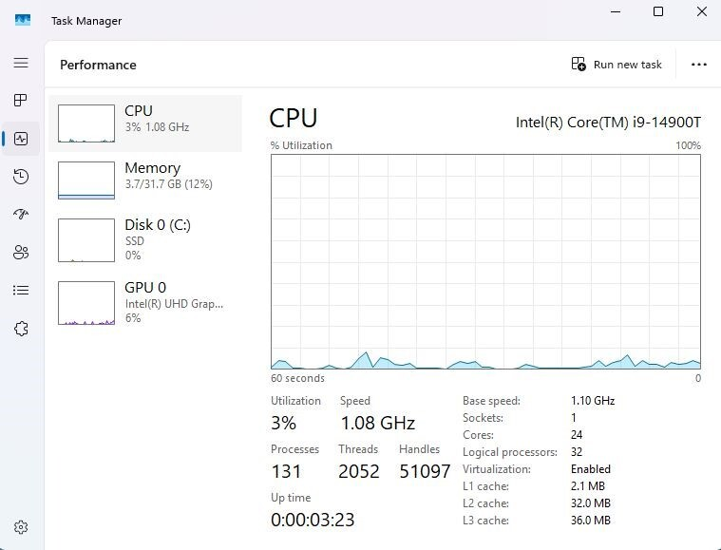

Access BIOS by pressing the Delete key repeatedly during the computer booting sequence
- Restart the computer.
- Press the Delete key repeatedly during the initial boot sequence to enter the BIOS.
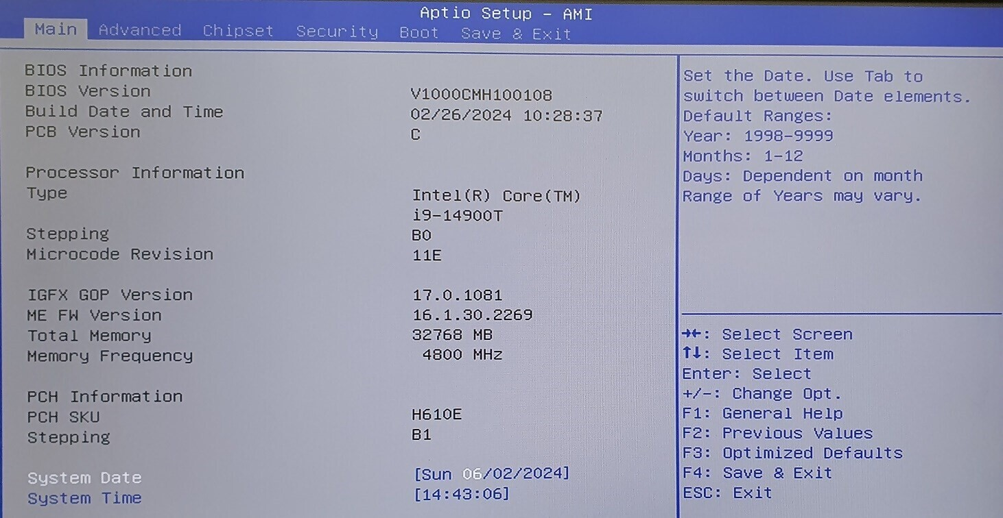

Navigate to the CPU Configuration Settings
- In BIOS, navigate to the Advanced tab.
- Select CPU Configuration.
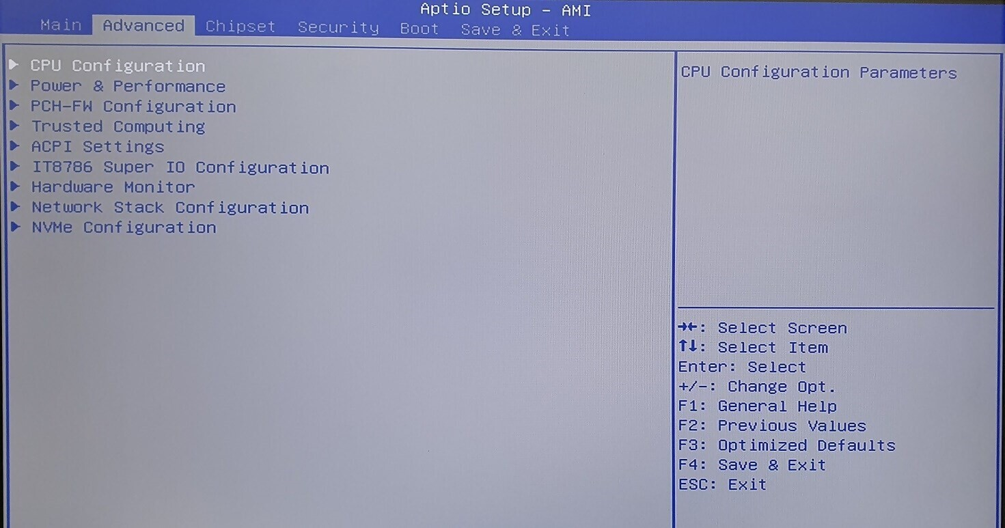

In the CPU Configuration Settings
- Locate the Hyper-Threading option.
- Change the setting from Enabled to Disabled.
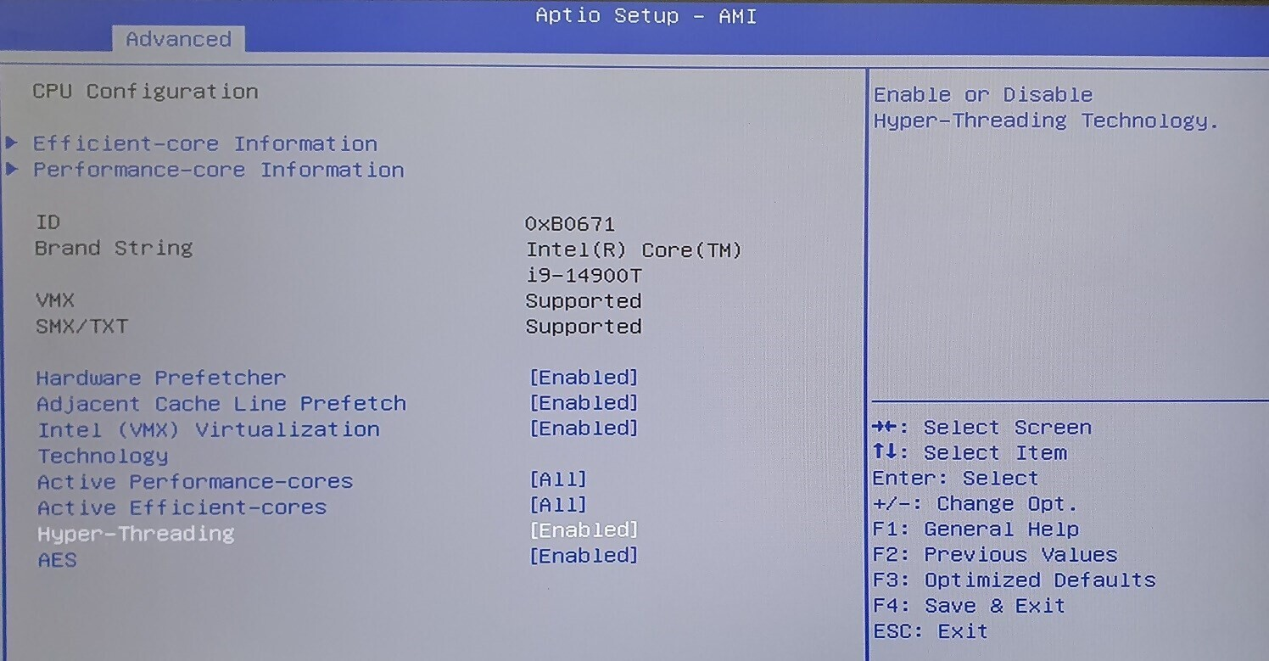

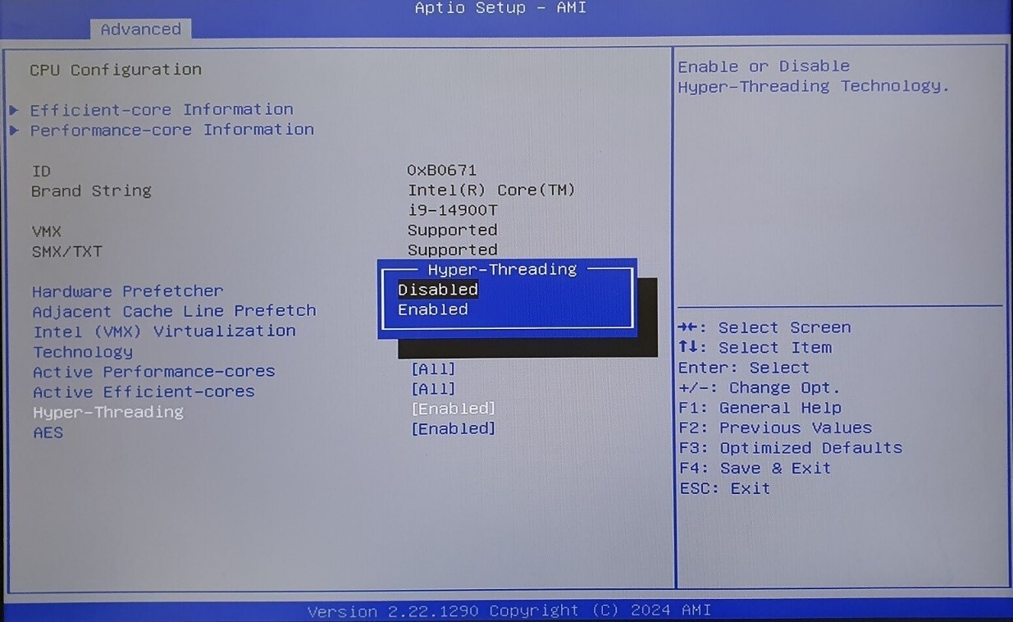

Confirm the Change
- Verify that Hyper-Threading is disabled.
- Exit the CPU Configuration screen.
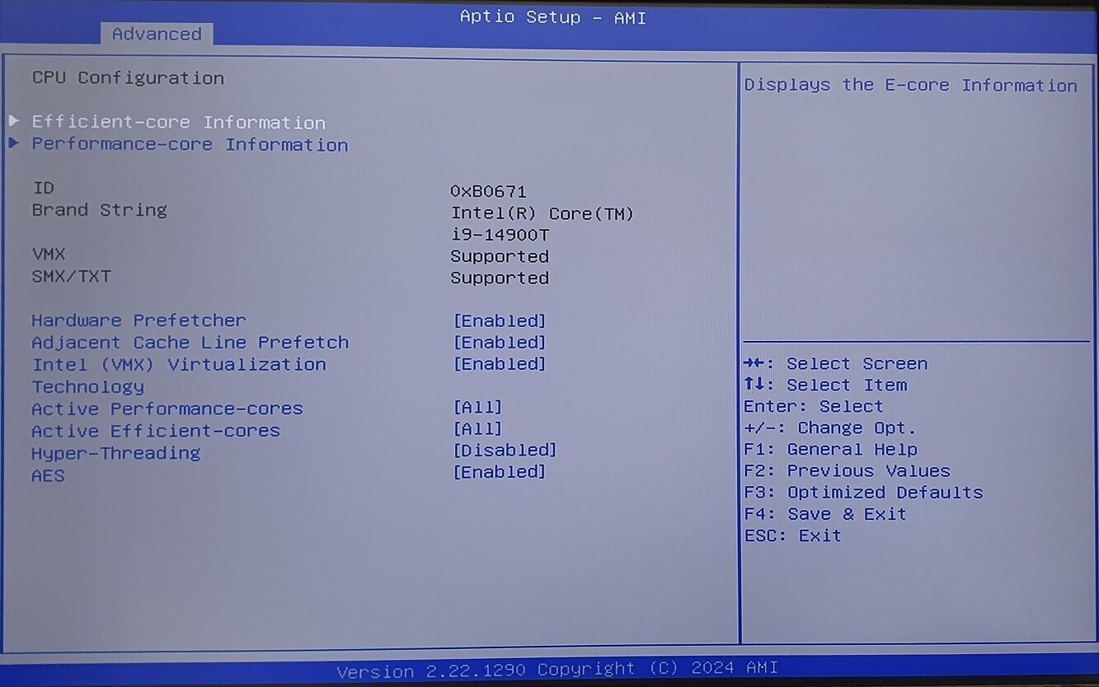

Configure Serial Port

Navigate to the IT8786 Super IO Configuration
- In BIOS, navigate to the Advanced tab.
- From the Advanced tab, select IT8786 Super IO Configuration.
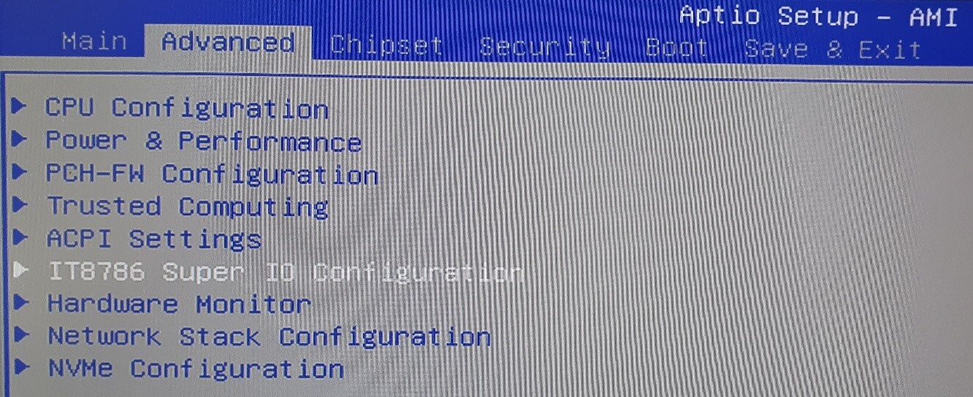

Configure Serial Port 1
- Inside the Super IO Configuration, choose Serial Port 1 Configuration.
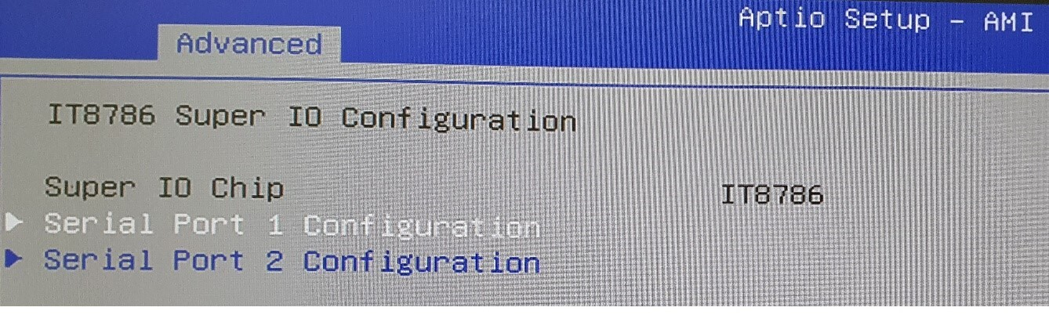

- Select the Device Mode setting [RS232].
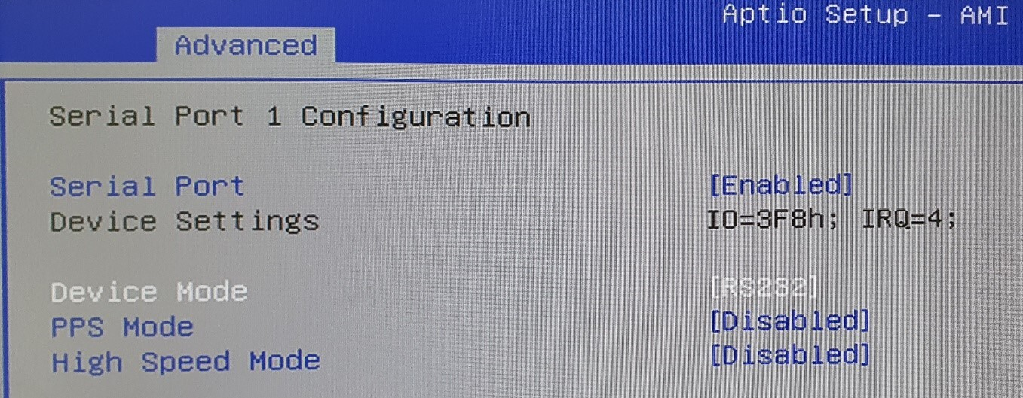
- Change the Device Mode setting to [RS422].
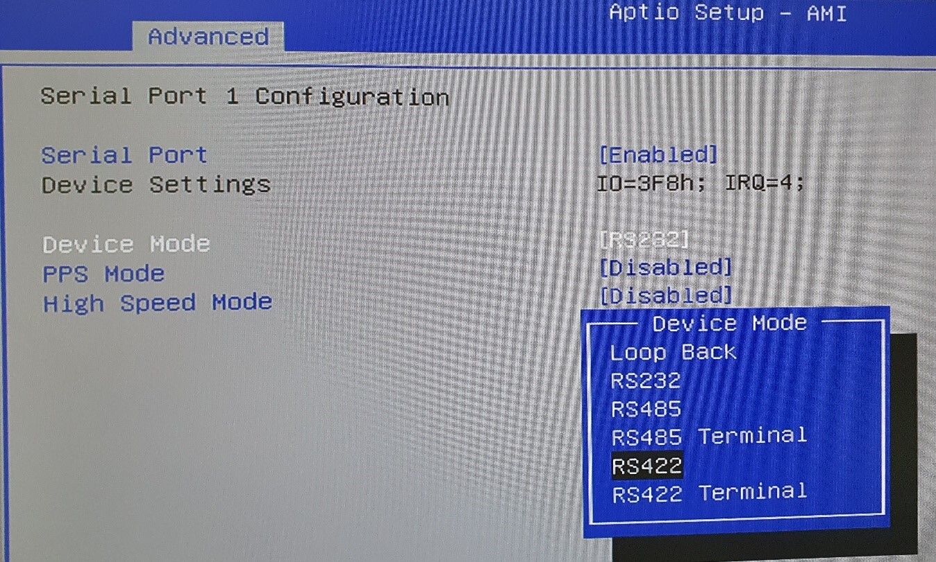

Verify the Configuration
- Confirm that Device Mode is set to [RS422].
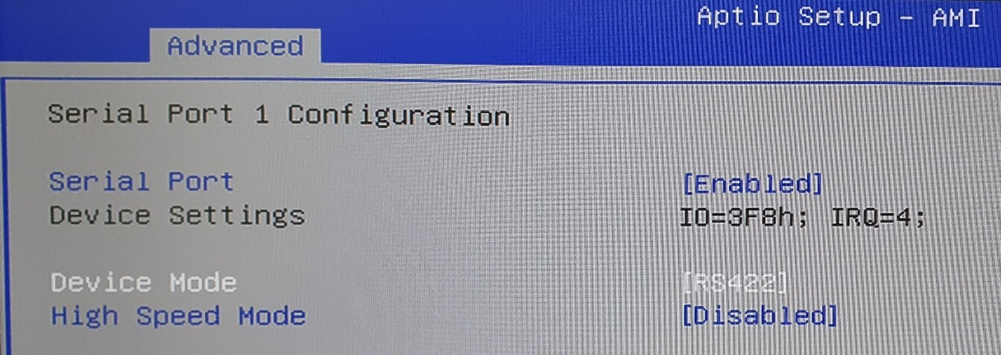

Configure Power On

Navigate to the Chipset Configuration Settings
- In BIOS, navigate to the Chipset tab.
- Select PCH-IO Configuration.
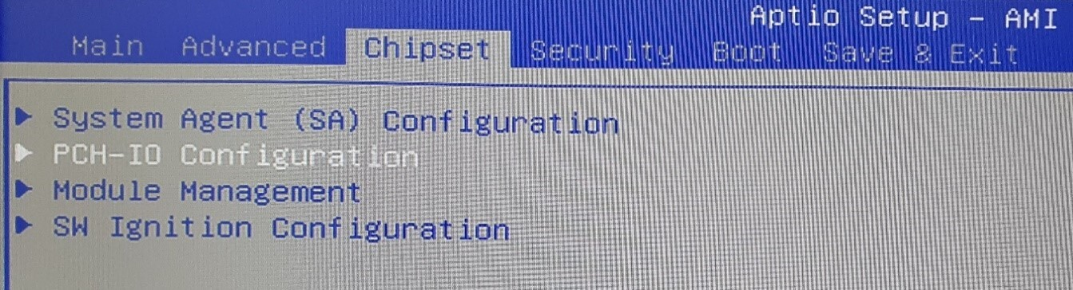

- Inside the PCH-IO Configuration, choose State After G3.
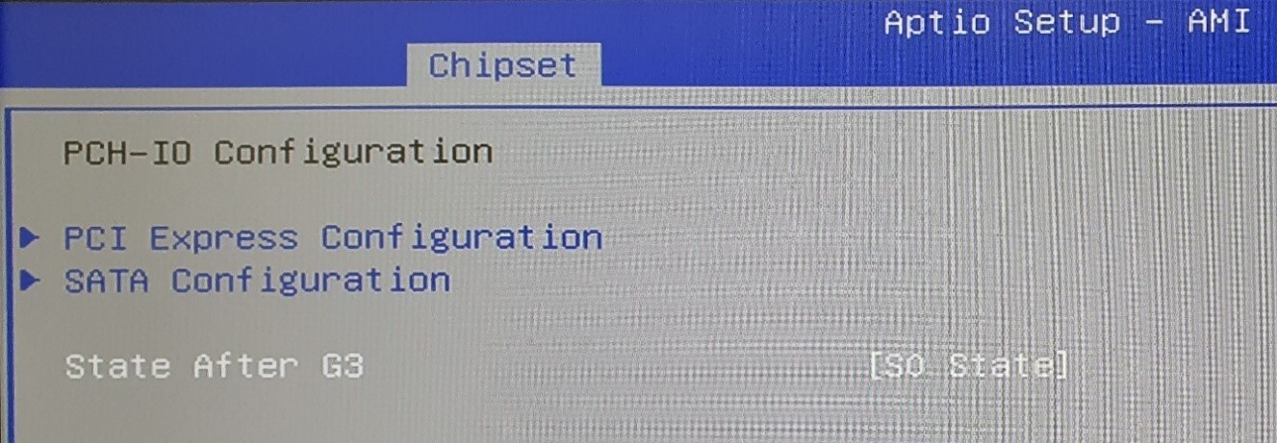

- Inside the State After G3, choose S0 State and press Enter.
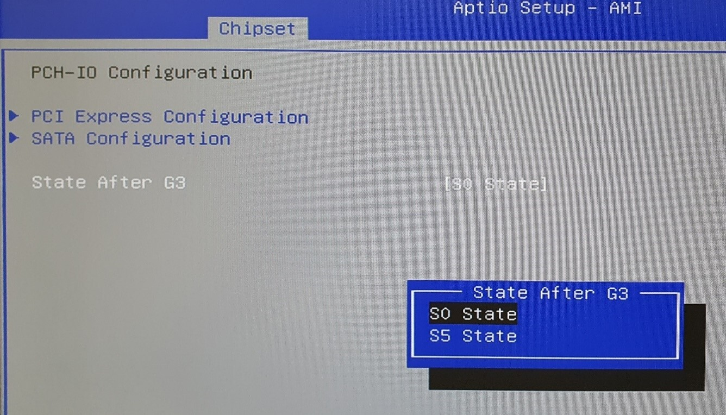

Save and Exit BIOS
- Press F4 to save changes.
- Select Yes to confirm and exit the BIOS.
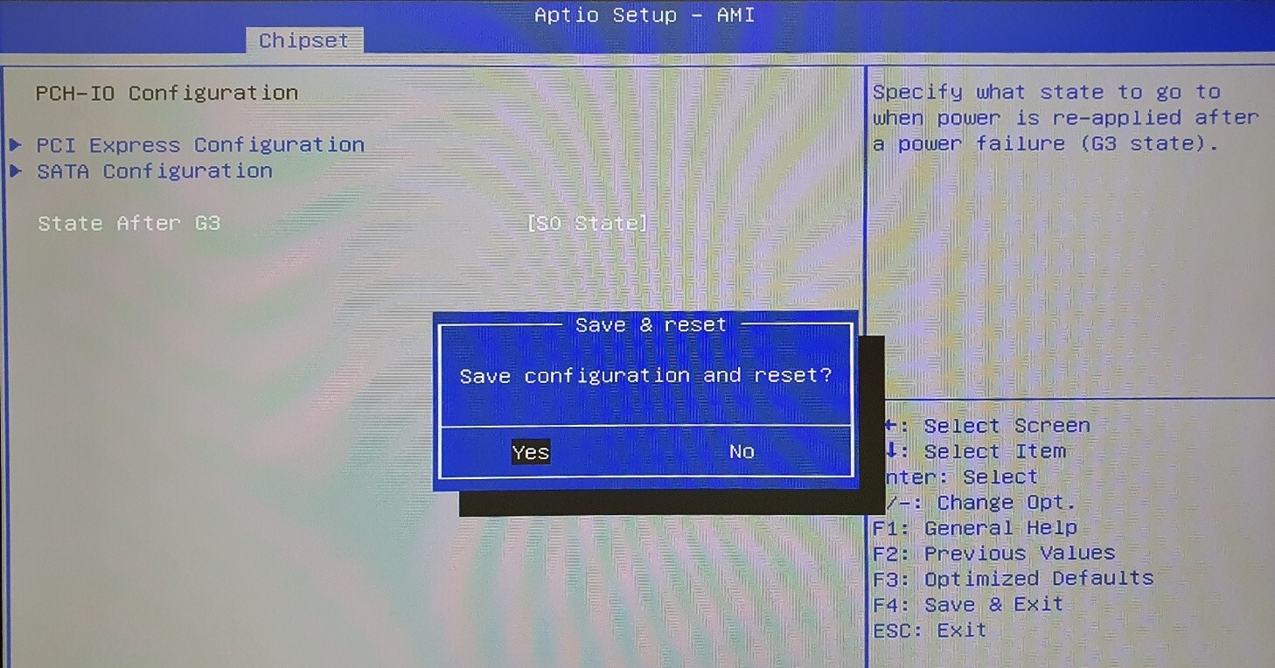

Verify BIOS Changes in Task Manager
- Open the Task Manager.
- Navigate to the Performance tab.
- Confirm that Hyper-Threading is now disabled (only 24 logical processors are visible).

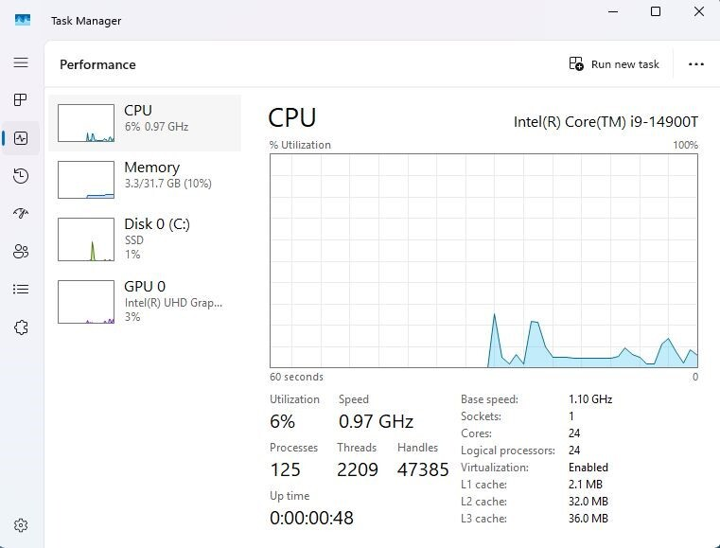

System Configuration
The computer on which the GVDM application executes has two Network Interface Cards (NICs), pivotal components of the data message routing process between the AGCS and the IVDM. At the start of the GVDM application, it reads the predefined IP addresses for both NICs from an external configuration file.
Before executing the GVDM application, it is essential to configure the IP addresses for the NICs manually. This configuration must be done at least once during the initial computer setup and preparation and as needed if the IP addresses of the GVDM NICs need to change.
The required configuration can be done through the user interface of the operating system network connections on the computer where the GVDM application is running. The IP addresses configured in the operating system must precisely match those specified in the configuration file. It is worth noting that the data in the configuration file remains intact even after the GVDM application is shut down.
The AGCS NIC must be configured to communicate with the AGCS using four fixed IP addresses: 91.100.8.30 with a subnet mask of 255.255.0.0, 93.100.1.67 with a subnet mask 255.255.0.0, 91.100.6.5 with a subnet mask 255.255.255.0 and 91.100.8.2 with a subnet mask 255.255.0.0.
The IVDM NIC must be configured to communicate with the IVDM using a variable IP address, e.g., 222.109.81.64, with a subnet mask 255.255.255.0.
Any changes to the system’s NIC IP addresses require updating the configuration file to ensure consistent connectivity and functionality.

Network Interface Cards Configuration

Open Command Prompt
Type `cmd` in the Windows Search bar and press Enter to Open Command Prompt.


Open Network Connections
Type `ncpa.cpl` in the command prompt and press Enter to open the Network Connections window
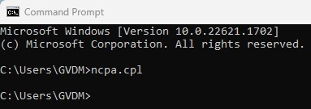

Rename NICs
In the Network Connections window, right-click each NIC and rename them AGCS and IVDM according to the following instructions. The instructions ensure that Ethernet connection LAN1 is configured to communicate with AGCS while Ethernet connection LAN2 is configured to communicate with IVDM.
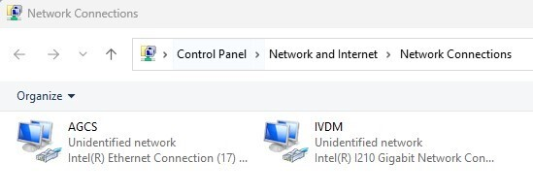

Rename NIC that uses Intel(R) Ethernet Connection (17) I219-V to AGCS
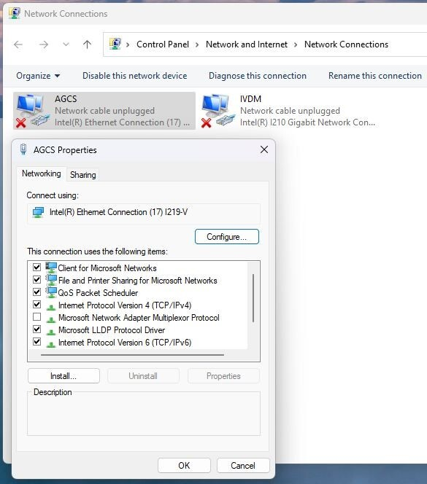

Rename NIC that uses Intel(R) I210 Gigabit Network Connection to IVDM
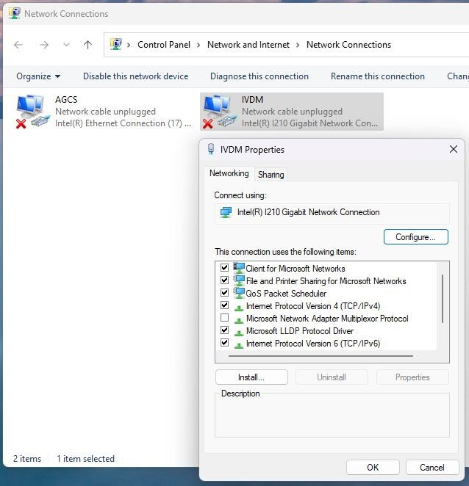

Configure the IP Address for the AGCS NIC
  - Right-click the AGCS NIC and select Properties.
  - Select "Internet Protocol Version 4 (TCP/IPv4)" and click Properties.
  - Select "Use the following IP address".
  - Enter the IP address for the AGCS NIC: 91.100.8.30 and the subnet mask: 255.255.0.0.
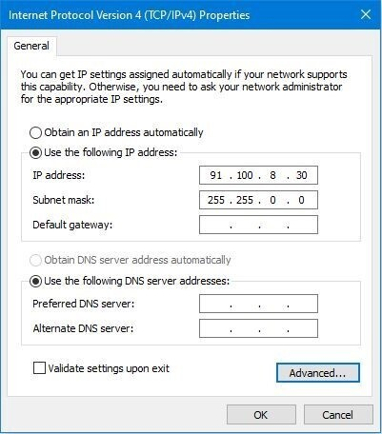
  - Click "Advanced..." to open the “Advanced TCP/IP Settings” window, and then click "Add..." to add an IP address.

  - Add the IP address 93.100.1.67 with a subnet mask 255.255.0.0, then click "OK" to save the settings and close the window.
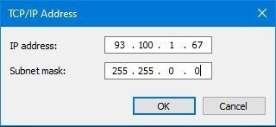
  - Similarly, add two additional IP addresses, 91.100.6.5 with a subnet mask 255.255.255.0 and 91.100.8.2 with a subnet mask 255.255.0.0. then click "OK" to save the settings and close the window.
  - Click "OK" to save the settings and close the “Advanced TCP/IP Settings” window.
  - If the instructions were followed correctly, the IP addresses for the computer’s AGCS NIC should be successfully configured and should look exactly like this:
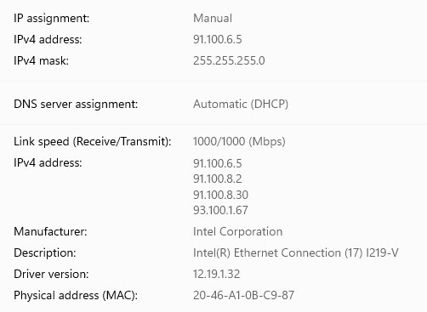

Configure the IP Address for the IVDM NIC
- Right-click the IVDM NIC and select Properties.
- Select "Internet Protocol Version 4 (TCP/IPv4)" and click Properties.
- Select "Use the following IP address".
- Enter the chosen IP address for the IVDM NIC, e.g., 222.109.81.64, and the subnet mask 255.255.255.0.
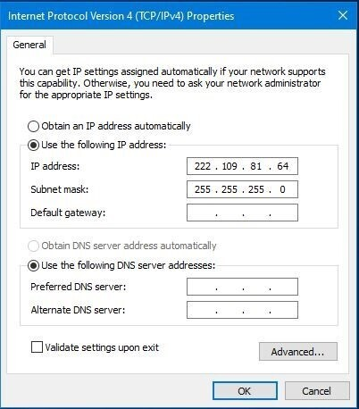
- Click "OK" to save the settings and close the "Internet Protocol Version 4 (TCP/IPv4) Properties” window.
- If the instructions were followed correctly, the IP addresses for the computer’s IVDM NIC should be successfully configured and should look exactly like this:
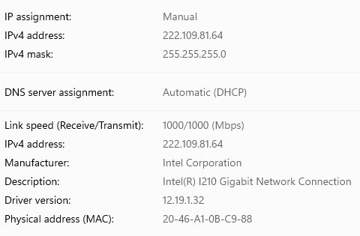

performance optimization

Disable Fast Startup
- Go to Control Panel > Power Options > Choose what the power buttons do.

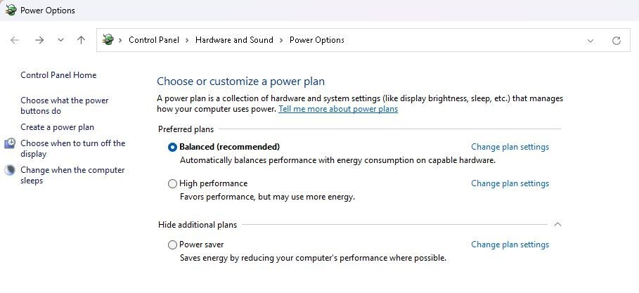

- Click Change settings that are currently unavailable.
- Uncheck Turn on fast startup (recommended) and save changes.
- Set When I press the power button to Shutdown
- Set When I press the sleep button to Sleep
- Uncheck Turn on fast startup (recommended) and save changes.

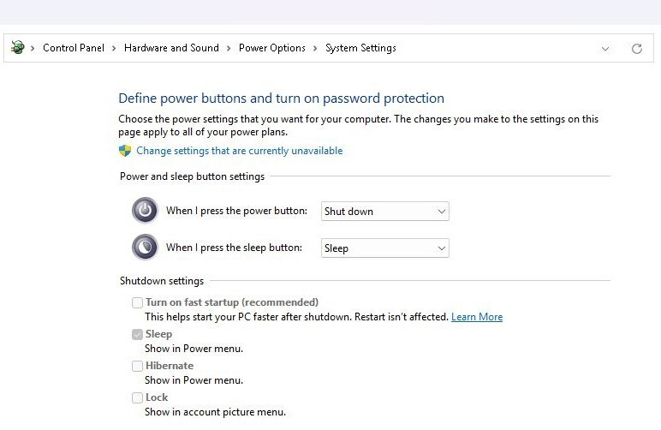

Configure System Power Settings
- In System Power, update the following settings:
- Set Turn my screen off after to Never.
- Set Make my device sleep after to Never.
- Set Make my device hibernate after to Never.
- Set Always use energy saver to Off.
- Set Pressing the power button will make my PC to Shutdown.
- Set Pressing the sleep button will make my PC to Sleep.

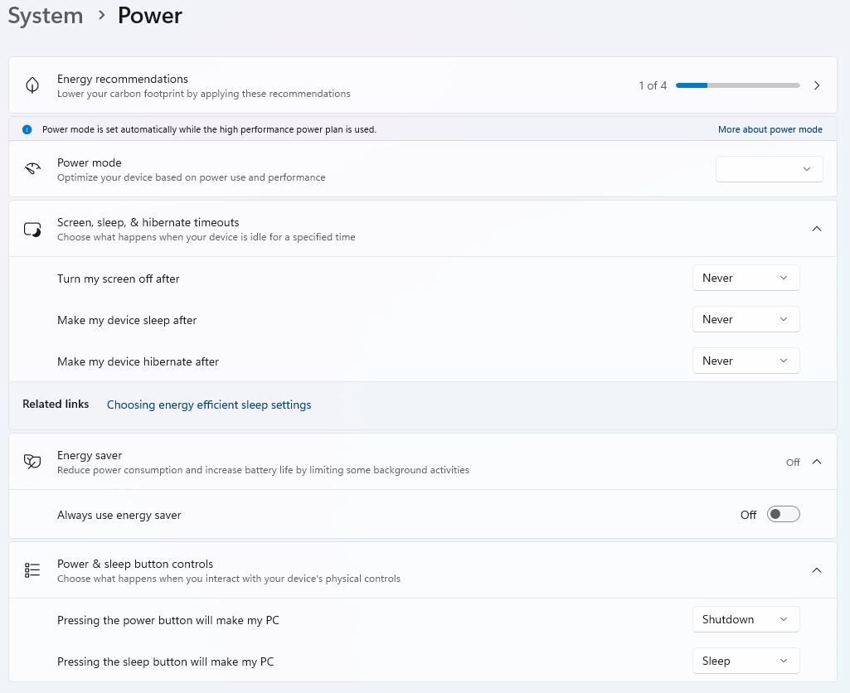

Configure System Display Graphics

- Navigate to System Display Graphics.
- Set Optimizations for windowed games to Off.

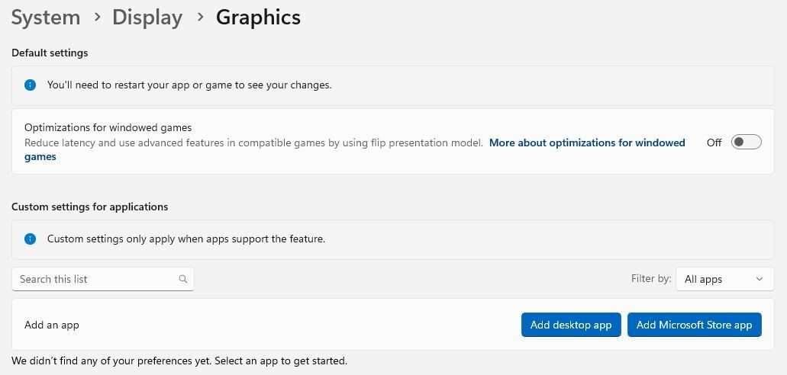

Adjust Game Bar Settings

- Navigate to the Game Bar in System Settings.
- Set Allow your controller to open Game Bar to Off.

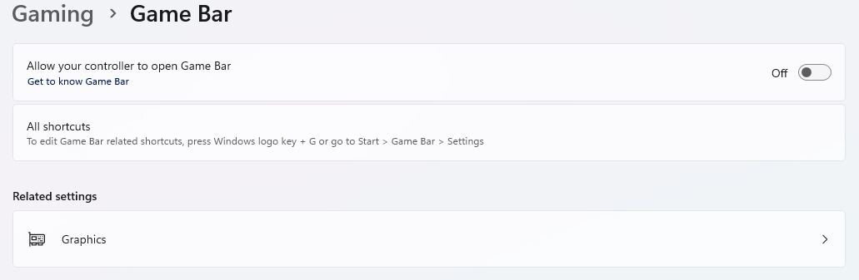

Adjust Visual Effects for Performance
- Locate and open Adjust the appearance and performance of Windows in System Settings.

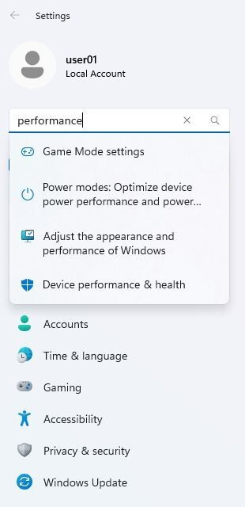

- In the Performance Options pop-up window:
- On the Visual Effects tab, select the Adjust for best performance radio button.

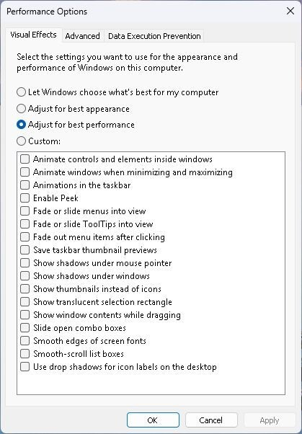

- On the Advanced tab, select the Background services radio button.

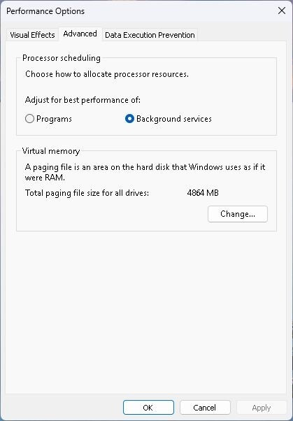

Manage Startup Applications

- Locate Startup Applications (Apps) in System Settings.
- Set all Startup Apps to Off.

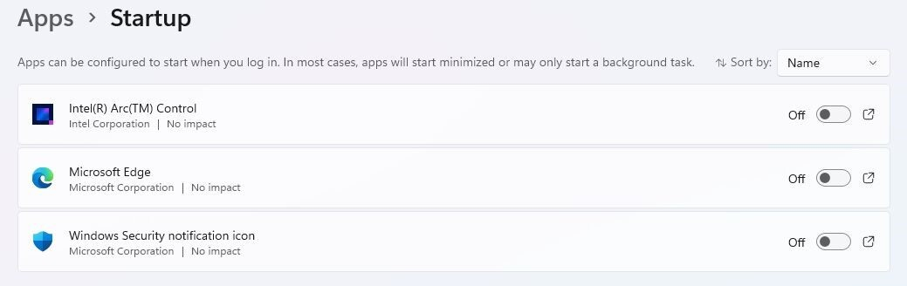

Adjust Firewall & Network Protection

- Open Firewall & network protection in System Settings.
- Set Domain Networks Firewall to Off
- Set Private Networks Firewall to Off
- Set Public Networks Firewall to Off

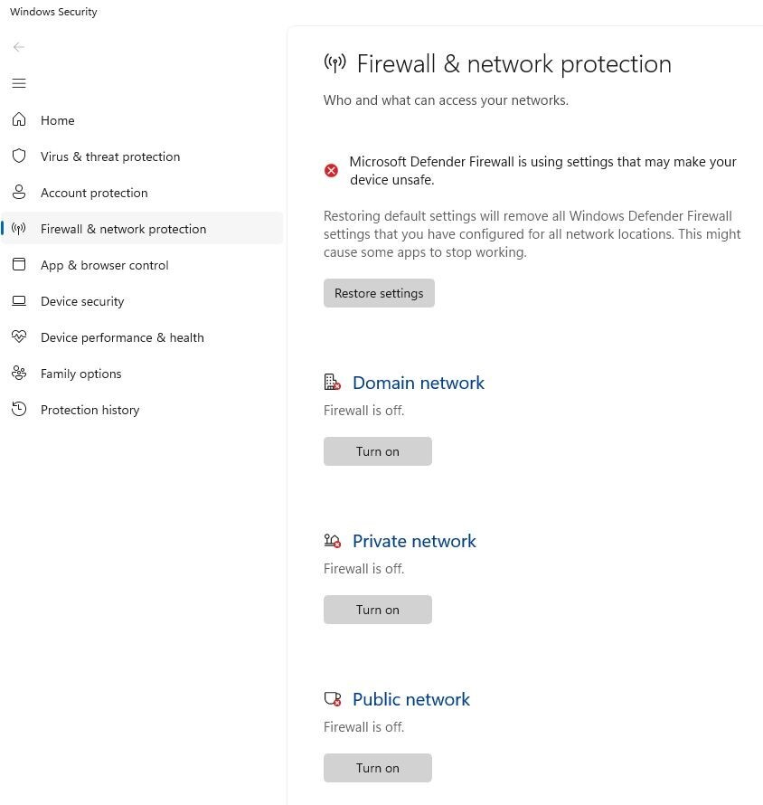

Turn Notifications Off

- Open Notifications in System Settings.
- Set all Notifications to Off

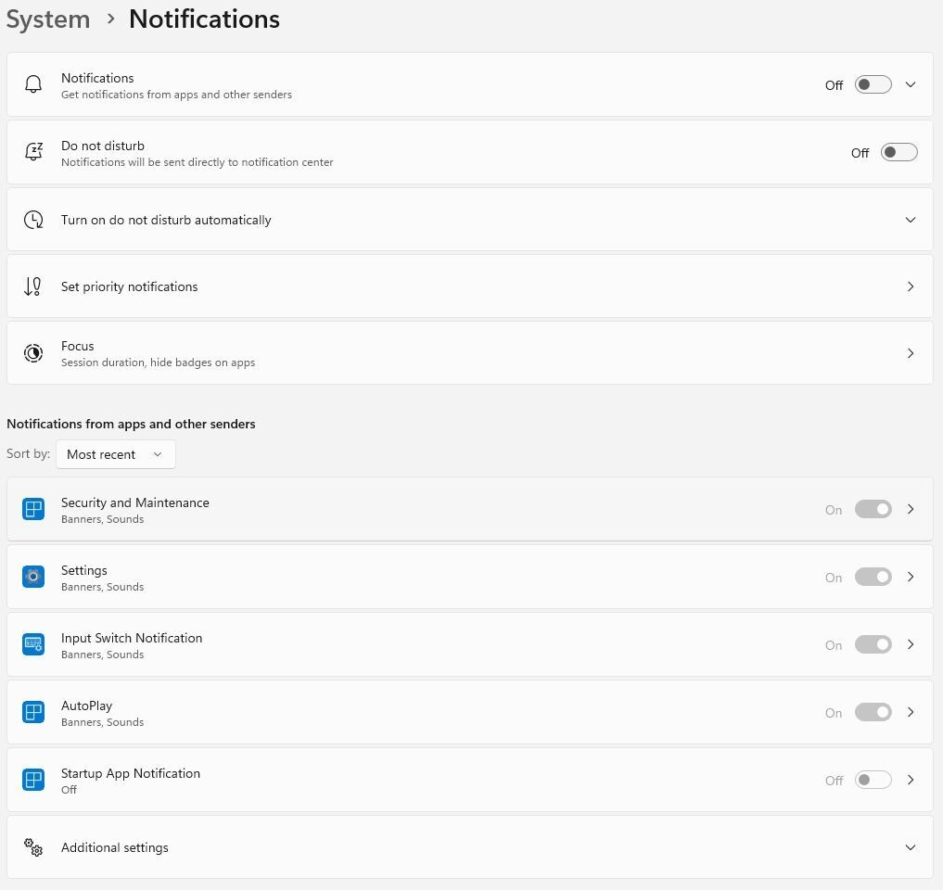

Update Time & Language Settings

- Navigate to Time & Language in System Settings.

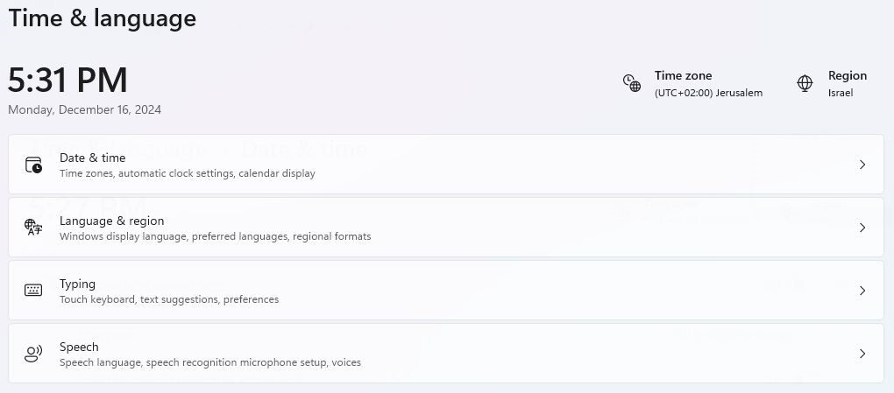

- Set Date & Time to your current time.

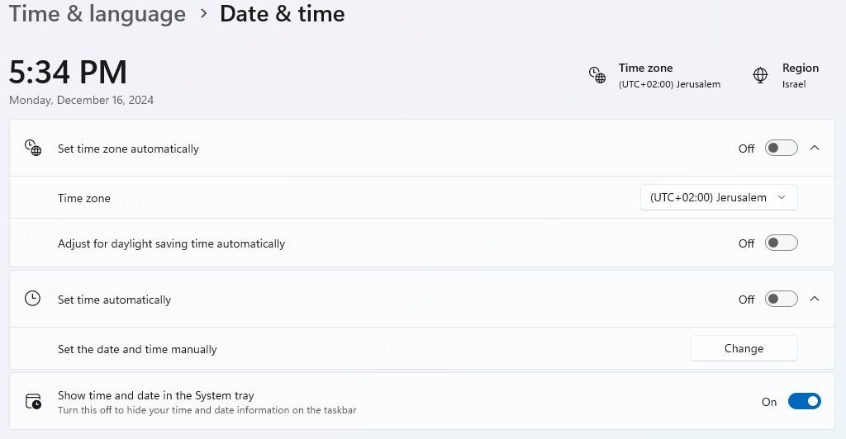

- Language & Region:

  - Remove Hebrew language entirely.
  - Set Windows display language to English.
  - Set Country or region to Israel.
  - Set Regional format to Recommended.

